**How to run multi environments using Pages.yml File**

The instructions below descript how to setup up a café script to run in multi environments. One script can execute in several different environments, and use different data set for each environment.

All the url information is stored in the pages.yml file, instead of the environment.yml , and the DEFAULT_ENVIRONMENT is set to blank in the Settings.yml file. By using this method complete urls along with any necessary parameters can be reference in a Scenario Outline, Example steps in the café script.

Steps:

1. Set the DEFAULT_ENVIRONMENT to blank in the settings.yml file



1. Define complete URLs to be used in the pages.yml file. A good naming convention is needed so when the file grows it is easy to read. First three letters being tool, second three letters being environment, and rest being description of page. For example HOS for hospital, B1, UAT, SYS being environment and Home being description of page

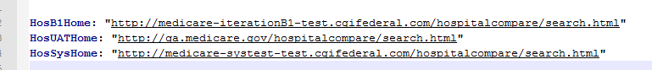

1. After the Urls are defined in the pages.yml file, then the page definition can be used in the script, along with the data used for that page by using the Scenario Outline Examples steps

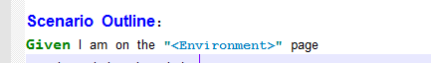

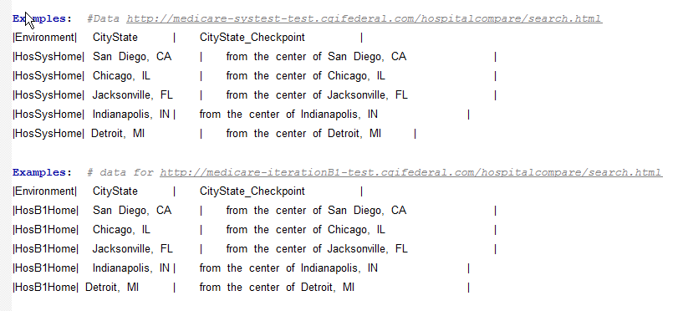

1. Several Example sections can be used in a café script allowing each environment to have its own section. By adding a comment to the example section makes both the script and results more readable.

Comment in script:



Produces Comment in results.

